Investigating the maths inside:

Big data, better hospitals
  - Information for teachers
Maths Inside is a project funded by the Commonwealth Department of Education and Training under the Australian Maths and Science partnership Programme.
The aim of Maths Inside is to increase engagement of students in mathematics by using rich tasks that show the ways mathematics is used in real world applications.

The data used in these activities have been provided by Queensland Health’s Healthcare Improvement Unit and are used with their approval.

About this module
This resource was developed by
David Andrew
Kym Linke
Kate Manuel
Stuart Palmer

UTS project team
Dr Marco Angelini (Project Manager)
Dr Mary Coupland (Project Director)
A/Prof. Anne Prescott (Project Director)

This module consists of the video The Patient Admission Prediction Tool and the following activities:
Activity 1: Errors and the power of percentages (Years 7, 8, 9 and 10)
Activity 2: What happened? (Years 7, 8, 9 and 10)
Activity 3: Difficult to easy (Years 8, 9 and 10)
Activity 4: Waiting, waiting (Years 10 and 11)

Background
Overcrowding in hospitals is one of the biggest challenges facing our healthcare systems. In order to reduce hospital waiting times, the Patient Admission Prediction Tool (PAPT) uses historical data to predict how many patients are expected to arrive at the Emergency Department every day of the year.

  - Activity 1: Errors and the power of percentages
Students use real data to compare the daily forecast with the actual number of people who came to the Emergency Department of a hospital to evaluate the effectiveness of the PAPT.

Why do this?
Students will gain insight into the way in which a prediction tool can be evaluated. They will calculate absolute, relative and percentage errors, and compare the usefulness of the measures.

Australian Curriculum links

Year 8: Numbers and Algebra - Real numbers
Solve problems involving the use of percentages, including percentage increases and decreases, with and without digital technologies (ACMNA187)

Year 10: Statistics and Probability - Data representation and interpretation
Evaluate statistical reports in the media and other places by linking claims to displays, statistics and representative data (ACMSP253)

Getting started
Ask students to brainstorm situations in which an estimation or an approximation can be used. Some suggestions:
- Our estimated time of arrival is 3:45 pm.
- Approximately 95% of trains leave this station on time.
- A 375 millilitre can of soft drink contains approximately 9 teaspoons of sugar.
The stimulus questions should lead to discussion about things which can’t be precisely measured, counted or calculated, and/or where accuracy is not vital.

Estimating and measuring
Show the students a doll (such as a Barbie) and ask them to estimate its height in centimetres (to the nearest centimetre). Then ask the students to estimate your height, also in centimetres (to the nearest centimetre). Students record their estimates.
Measure the doll (this may be a good opportunity to discuss rounding up or down). State your height. Students then compare their estimated heights to the measured heights. Ensure that they also record if their estimate was over or under.
It may be helpful to get the students to enter their estimates into an online form, such as Google Drive or Survey Monkey, so that the students’ estimates are compiled in a spreadsheet. Students could then perform statistical calculations of the data set containing their estimates.

Discussion questions
It may be best to ask students to discuss these questions in a small group first and then with the whole class.
It is important for students to realise that over-estimating both heights by 3cm is not ‘equal’. The 3cm should be compared to the actual height of the object being estimated. The best way to do this is by using percentage error.
The discussion should lead to a method for using percentages to choose the ‘best estimator’. One approach could be to average the percentage error for the doll’s height estimate and the teacher’s height estimate. You may wish to give a prize to the winner.

How accurate?
The concept and calculation of ‘percentage error’ is explained in ‘student-friendly’ terms on this webpage: https://www.mathsisfun.com/numbers/percentage-error.html
It has been decided to use positive and negative percentage errors to differentiate between over-estimates and under-estimates. If the ‘mean percentage error’ is going to be calculated, all the percentage errors must first be made positive.
The Patient Admission Prediction Tool is used to forecast the number of patients who will turn up to a hospital on any given day of the year.
For example, on 28 June, the forecast was 206 people but the actual number was 221.
The forecast was 15 below the actual. This error could be written as .
Percentage error:
Data for predicted and actual numbers of admissions in the first 20 days in July are provided. Ask each student, or group of students, to calculate the percentage error for one (or more) days and then write the error for each day on individual sticky-notes.
The answers for the first two days are given. Record these on sticky-notes as well.
Ask students to arrange the sticky-notes in order of magnitude of the error to answer these questions.
Number of days for which the forecast was an under-estimate.
Number of days for which the forecast was correct.
Number of days for which the forecast was an over-estimate.

Number of days for which the forecast was less than 5% above or below or actual.
Number of days for which the forecast was less than 10% above or below or actual.

Discussion questions
Students may notice that the largest error was more than 30%. What is a reasonable error? Will that reasonableness change depending on the context?

Five years of data
The provided spreadsheet contains the forecast and the actual numbers of patients every day for the five-year period from July 1 2009 to June 30 2014.
Students in a class could be divided into, say, 10 groups. Each group could be given data from a six-month period, to assess whether the accuracy of the PAPT changes over time.
The graph below indicates that there has been improvement.
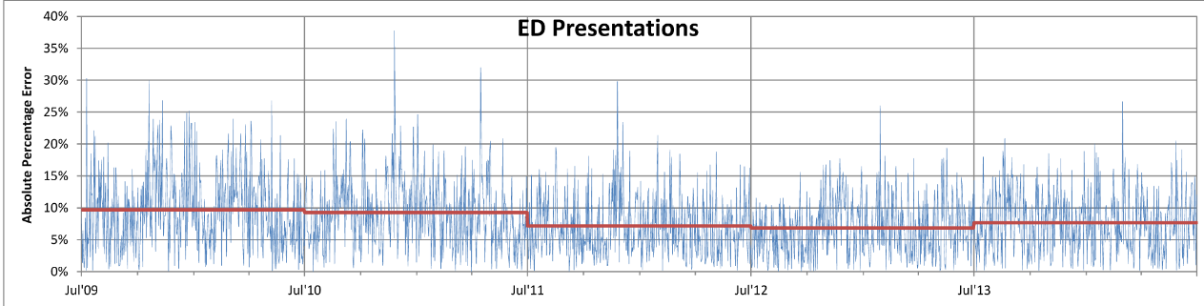

Answers

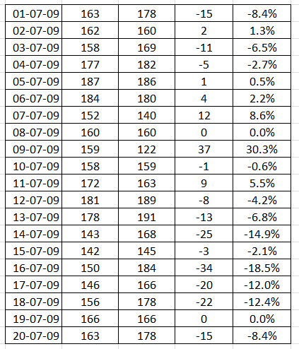

Number of days for which the forecast was an under-estimate. | 12
Number of days for which the forecast was correct. | 2
Number of days for which the forecast was an over-estimate. | 6

Number of days for which the forecast was less than 5% above or below or actual. | 9
Number of days for which the forecast was less than 10% above or below or actual. | 11

Resources needed
A doll (such as Barbie)
Measuring tape
Twenty (20) sticky notes, approximately 10cm x 10cm
Optional: Prize(s) for the ‘best estimator(s)’.

Further ideas
Following this, students could investigate the accuracy of the weather forecast in their area. For example, they could investigate:
- The forecast maximum temperature compared to the actual maximum temperature.
- The probability of rain (given as a percentage) compared to whether or not it rained.

  - Activity 2: What happened?
Students arrange themselves in height order to establish a firm understanding of the median and interquartile range, in preparation for constructing boxplots. They analyse the number of competition points scored by each of the 18 teams in the 2016 Australian Football League regular season. Students then analyse and compare four data sets from the PAPT. They attempt to explain apparent anomalies, and are led to the correct conclusion through a series of hints.

Why do this?
In the teaching of statistics, it is important for students to analyse and describe real data. However, students should be thoughtful when choosing the types of analyses to apply, and when drawing conclusions, as the context of the situation needs to be taken into account.

Australian Curriculum links

Year 7: Data representation and interpretation
Identify and investigate issues involving numerical data collected from primary and secondary sources (ACMSP169)
Calculate mean, median, mode and range for sets of data. Interpret these statistics in the context of data (ACMSP171)

Year 8: Data representation and interpretation
Investigate the effect of individual data values, including outliers, on the mean and median(ACMSP207)

Year 10: Data representation and interpretation
Determine quartiles and interquartile range (ACMSP248)
Construct and interpret box plots and use them to compare data sets (ACMSP249)

Getting started
Ask “If all the students in our class were lined up from shortest to tallest who would be in the middle of the line? Who would be at either end? Can we divide our class into four equal groups?” Record responses.
  - Select thirteen students and have them line up in height order. Who is in the middle? Can we divide them into four groups (i.e. quartiles)? Are the quartiles the same size?
Add one more student and reorder. Who is in the middle now? Discuss. Can we divide them into four groups? Is it easier or harder to do this?
Add another student and repeat the exercise.
Add yet another student and repeat the exercise.
Students should realise that there can be two people in the middle. One way of handling this is to average the two heights.
There are a number of algorithms for finding quartiles; in large data sets different methods are unlikely to cause issues. The Australian Curriculum does not specify a method for students to use.

2016 AFL competition
The purpose of this activity is to introduce (or consolidate) the use of boxplots for displaying data. The length of the whisker indicates the amount of spread within that quartile of the data. The right whisker is very short compared to the left whisker. Also, the median is not in the middle of the box.
Students could be asked to use technology to draw the box plot. They may find that different technology gives different values for the lower quartile. In the boxplot below the lower quartile (28) is given by the median of the nine teams in the bottom half of the ladder.
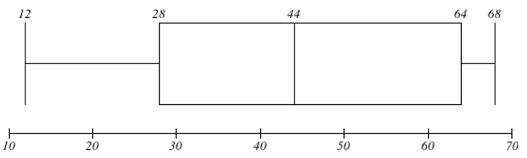
In the AFL example, different algorithms give different values for the lower quartile.
This website calculates the lower quartile to be 27.
http://www.alcula.com/calculators/statistics/box-plot/
In Excel, there are two different formulas for finding the quartiles.
QUARTILE.EXC returns a value of 27
QUARTILE.INC returns a value of 29
This website will draw a boxplot (or two or three parallel boxplots on the same scale).
http://www.imathas.com/stattools/boxplot.html
The user is required to input the 5-number summary, which will limit the confusion described above.

My data set
Print the download with the data sets (MI_PAPT_Activity2_WhatHappened_DataSets) and cut into four strips.
Print the download with the labelled number lines (MI_PAPT_Activity2_WhatHappened_NumberLine1) and cut into four strips.
Print the download with the blank number lines (MI_PAPT_Activity2_WhatHappened_NumberLine2) and cut into four strips.
Divide the class into four groups. Give each group a different set of data and one labelled number line. Keep the blank number lines until they are needed.
Data set 4 has two very large data values, therefore that group will need to extend the given scale onto the blank number lines. They will need to sticky-tape the strips together.
Once all the groups are finished, display the four boxplots, one above the other, on a wall of the classroom. Discuss.

What was counted or measured? What happened?
Turn this into a guessing competition!
Print the download with the entry forms (MI_PAPT_Activity2_WhatHappened_EntryForms) and cut into individual forms. Give each student two or three entry forms onto which they write their name. Alternatively, this could be done using SurveyMonkey or a Google Form.
There are a series of twelve hints. Read them out one by one.
As the hints are provided, students write their guesses onto the forms and place them face down in a pile on a desk at the front of the room. Students can make up to three guesses. After the last hint is read out, when all students have finished guessing, the pile is turned over and entries are read out, starting with the very first guess.
Prizes could be awarded to the first three people who indicate that the outliers had something to do with Gold Coast Schoolies Weeks.

Hints
- The data was collected at one hospital in Australia.
- The four box plots each contain 13 data values.
- How many weeks are there in one year?
- The hospital is NOT in the capital city of a state or territory.
- The data values represent the number of people who turned up to a particular department of the hospital.
- The data values were given to you in chronological order, according to the weeks of the year.
- Most of these people walked to the hospital, but some were brought by ambulance or police.
- The hospital is on the east coast of Australia.
- This sudden spike in the number of people occurs every year at roughly the same time.
- The event that is associated with these injuries was mentioned in the PAPT video.
- Many of the injuries in Weeks 47 and 48 were associated with people affected by alcohol or drugs.
- The majority of the people injured in Weeks 47 and 48 were aged 17 or 18.

Answers
 | Minimum value | Lower quartile | Median | Upper quartile | Maximum value
Set 1 | 74 | 79.5 | 89 | 102.5 | 115
Set 2 | 68 | 74.5 | 81 | 92 | 103
Set 3 | 63 | 73.5 | 80 | 85 | 118
Set 4 | 72 | 78 | 84 | 95 | 534

The data comes from the Emergency Department in a Gold Coast hospital. Admissions are relatively stable throughout the year but show a marked increase during Schoolies Weeks. The graph below shows the ‘spike’ in the number of people turning up to the Emergency Department during November. It is interesting that people aged 17 (who can’t enter licensed premises) are represented more often than those aged 18 (who can legally enter such premises).
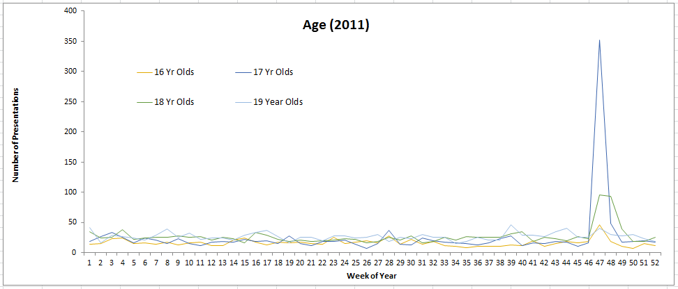

Resources
Access to a spreadsheet, the internet and/or a graphics calculator to draw boxplots
Download and print one copy (if working with four groups) of the data sets (MI_PAPT_Activity2_WhatHappened_DataSets)
Download and print one copy (if working with four groups) of the labelled number lines (MI_PAPT_Activity2_WhatHappened_NumberLine1)
Download and print one copy (if working with four groups) of the blank number lines (MI_PAPT_Activity2_WhatHappened_NumberLine2)
Download and print the entry forms (enough that each student can make several guesses) (MI_PAPT_Activity2_WhatHappened_EntryForms)
Sticky-tape
Blu-tack or similar
Optional: Prize(s) for the ‘best guess’

Further ideas
Set 4 provides a good opportunity to discuss the effect of outliers on the mean.
Set 4 | Median | Mean
All data values | 84 | 126
With two outliers removed | 83 | 83
Activity 3: Difficult to easy
Students are exposed to a variety of contemporary graphical representations of data. They examine representations of the more complex data from the PAPT to assist in their interpretation. Using a simple but relevant context, students construct their own heat-maps and 3D graphs, using Excel.

Background
In developing the Patient Admission Prediction Tool, a lot of data was collected over a number of years. That data was displayed using a variety of graphs which pulled together the complex information needed for analysis. The graphs were also used to explain to the decision makers, some of whom did not have a mathematics background, what the data meant. This activity considers only one of those graphs, the heat-map.
To learn more about heat-maps and their uses go to https://en.wikipedia.org/wiki/Heat_map

Why do this?
Students will come across a wide variety of graphical representations in the media. Being able to take what has been learned at school about data and graphs, and then transfer that knowledge to a new situation, is an important skill.
This activity extends students’ understanding that different graphs can be used to represent complex information. They will learn about heat-maps, which are used widely in industry and business, but which are not usually taught at school. Because the interpretation of heat-maps is quite difficult, the level of analysis required is general only.

Australian Curriculum links

Year 8: Data representation and interpretation
Investigate the effect of individual data values, including outliers, on the mean and median (ACMSP207)

Year 9: Data representation and interpretation
Compare data displays using mean, median and range to describe and interpret numerical data sets in terms of location (centre) and spread (ACMSP283)

Year 10: Data representation and interpretation
Investigate and describe bivariate numerical data where the independent variable is time(ACMSP252)
Evaluate statistical reports in the media and other places by linking claims to displays, statistics and representative data (ACMSP253)

Getting started
Have a class discussion. Why are graphs used? What types of graphs do students already know about? Where do you see graphical representations of data?

What does the data show?
The table contains data on the ways all the students travel to school. Ask students to point out similarities and differences in the values, and then to make some general statements.
Year level | Walk | Bus | Bike | Driven in car | Drive yourself
Year 7 | 43 | 29 | 12 | 40 | 0
Year 8 | 39 | 30 | 15 | 36 | 0
Year 9 | 45 | 24 | 19 | 28 | 0
Year 10 | 50 | 40 | 18 | 21 | 1
Year 11 | 30 | 45 | 11 | 22 | 12
Year 12 | 25 | 20 | 8 | 16 | 32

Which graph is best?
The first slides of the PowerPoint ‘Which graph is best?’ (MI_PAPT_Activity3_WhatHappened_WhichGraph) show six different ways of using Excel to graphically represent the travel data. Stop at Slide 8.
Ask students to critically appraise each graph. Students should be looking for suitable communication (such as headings, axes labels, suitable scales, legends) as well as how easy it is to notice patterns in the data.
This activity could be done as a whole-class exercise or in small groups.

Is there a better graph?
The Heat-map spreadsheet (MI_PAPT_Activity3_DifficultEasy_HeatmapData) contains data on the number of admissions for a large Queensland hospital in the month of March. The admissions are recorded hourly using 24-hour clock time. Students are to create a heat-map of the data using Excel.
Show the You Tube video ‘How to create a cool heat-map in Excel’ https://www.youtube.com/watch?v=CEGSBpNUZQ4. The video shows how to draw a heat-map table which has the data and the colours in the cells.
A heat-map only has colours. Removing the data highlights the patterns in the colours, which are related to the underlying data. It also signals blocks of colour which highlight groups of similar data.
There are further instructions in the download ‘How to create a heat-map in Excel’ which you should read. You may wish to hand out copies to students.
Ask students to write a short report on their finding and attempt to explain why that might be so.
There is a completed heat-map on Slide 9 of the PowerPoint.

More heat-maps
The final two graphs on the PowerPoint are ‘time-and-date-analysis’ heat-maps of:
- Treatment times for patients who leave the Emergency Department
- Patients being admitted to the Emergency Department
In groups, ask students to develop a series of dot points to explain these heat-maps. Thoughts can be shared with the class to add to the total picture.

Answers

What does the data show?
- Most students in Years 7, 8, 9 and 10 walk
- More Year 10 and 11 students catch a bus
- Numbers travelling by bike is similar for all year levels
- More Year 7 and 8 students are driven in a car than other year levels
- Many Year 12 students drive themselves

Which graph is best?
- The clustered column graph, the stacked area graph, the 3-D line graph and the radar graph could all be used but it is very hard to read values from the latter three
- The radar chart would be a poor choice as it does not show the patterns well
- The pie graph only shows one mode of transport
- The heat map does not have a legend to explain the blocks of colour
The clustered column graph is probably most suitable.

Is there a better graph?
- There are large green blocks in the morning, mainly between 5am and 10am, when there are either no admissions at all or low numbers of admissions.
- There is a general trend to more admissions in the afternoon, increasing mainly from 1pm through to 9pm.
- There is a decrease in admissions from 9pm through to 1am, and then admissions drop off dramatically.
The explanations should relate to the students own experiences and what is happening at various times during the day and night.

More heat-maps
In the ‘Treatment times for patients who leave the ED’ heat-map, students should notice that the vertical axis is numbered up to 60, representing 5 years of monthly data.
The graph shows the amount of time patients spend in the ED before being admitted to hospital. For example, patients who arrive at about 5 pm spend the longest time in the ED, while those that come at 8 am spend the least amount of time.
Students should also comment on the Averages bar at the bottom of the graph, and the legend of colours on the right-hand side. There is a clear pattern of colour change as you move across the graph.
In the ‘Admissions times to the ED’ heat-map, students should see that a change of colour is obvious as you move across the graph. The darker the colour, the fewer the patients being admitted per hour. It can be seen that more patients are admitted from 4 pm through to 10 pm.
The two graphs together show that the more patients in the ED, the longer it takes to attend to them and then admit them to the hospital. The fewest number of patients arrive between 6 am and 8 am, so they are assessed more quickly and admitted to hospital more quickly. Students should be able to have a discussion about why this occurs based on their own experiences about what is happening at different times of the day and night.

Resources needed
Access to computers and Microsoft Excel
‘Which graph is best?’ PowerPoint (MI_PAPT_Activity3_DifficultEasy_WhichGraph)
Spreadsheet ‘Heat-map data’ (MI_PAPT_Activity3_DifficultEasy_HeatmapData)
Download and print ‘How to create a heat-map in Excel’ (MI_PAPT_Activity3_DifficultEasy_HeatmapInstructions)

Activity 4: Waiting, waiting
Students identify common queueing situations and the factors that cause a queue to occur. They simulate simple queueing situations using concrete materials and then use spreadsheets for more complex modelling. Students change the factors to explore their effects. They then apply their knowledge to a hospital queue.

Background
The Patient Admission Prediction Tool (PAPT) uses data to predict admissions so that hospitals can make more informed decisions and allocate resources appropriately.
Emergency Departments in hospitals are very complex settings. Detailed examination of the numbers of arrivals and discharges, which could lead to queueing, is difficult. However, modelling simpler and familiar queueing situations develops some understanding of the issues.

Why do this?
In tackling real world problems, formulating a mathematical model to represent some aspect of the problem is essential. The process of improving and extending the model enables solution/s to be based on more realistic assumptions.

Australian Curriculum links

Year 7: Data representation and interpretation
Investigate and describe bivariate numerical data where the independent variable is time (ACMSP252)

Problem-solving proficiency
Students develop the ability to make choices, interpret, formulate, model and investigate problem situations, and communicate solutions effectively. Students formulate and solve problems when they use mathematics to represent unfamiliar or meaningful situations, when they design investigations and plan their approaches, when they apply their existing strategies to seek solutions, and when they verify that their answers are reasonable. Problem solving includes formulating, and modelling practical situations.

Getting started
Begin a class discussion.
What are some situations where people are required to queue? Are there certain behaviours expected of people in a queue? What is done to manage queues? What other queueing situations involve people indirectly?
Queues occur quite frequently: in supermarkets and other shops, at the school assembly hall, sitting at the traffic lights in a car, entering a sports venue, at the bus stop. Queues do not have to involve people physically; queueing can also occur on assembly lines, at call centres and waiting for internet connections, for example.

Simulating a queue in the classroom
Select four students.
- a server, to stand behind a desk/table ready to receive customers
- a timer, to indicate when 10 seconds has elapsed for each customer
- a roller, to roll a six-sided every 20 seconds to indicate how many new customers are added to the queue
- a recorder, to record the time each customer stays in the queue on a whiteboard.
The rest of the class will be the customers.
The activity starts when the die is rolled.
The number on the die indicates the number of customers arriving at one time (1, 2, 3, 4 or 5, with the 6 counting as a zero). Roll once to find out how many customers are waiting in the queue when the server begins serving. The server spends 10 seconds serving each customer. The timer needs to indicate when the 10 seconds is up, perhaps by ringing a bell.
The die is rolled every 20 seconds, the number on the die indicating the number of customers added to the queue.
Each customer notes the length of time that they waited (e.g. 0, 10, 20, 30 seconds) and relates the time to the recorder to scribe onto the whiteboard.
In this situation, the server is able to serve two customers every 20 seconds and have 0, 1, 2, 3, 4 or 5 customers arriving every 20 seconds. A queue is likely to form reasonably quickly, depending on the outcome of the roll of the die.

Observation
Does a queue form? When? What is the shortest waiting time? The longest? How long is the longest queue? Are there any times where customers do not wait?

Changing the situation
Explore different ways of preventing the queue from growing (e.g. select another server so that two customers can be served every 10 seconds).
Does this slow down the growth of the queue? Does this lead to either of the servers not serving? This is called idle time.

Exploring simple queues
Ask students to complete the first table on their worksheet (MI_PAPT_Activity4_Waiting_Tables) paying particular attention to their calculations to determine the ‘number of customers in queue’.
Ask them to explore a queue by randomising the number of customers arriving each minute using the square spinner provided (MI_PAPT_Activity4_Waiting_Spinner) or a tetrahedron die, and to fill in the second column ‘number of customers that arrive’.
Students complete the third column, ‘number of customers served’, with a one in each row.
To start the fourth column, students need to subtract 1 from the number in the second column to determine how many people are left standing in the queue after the first minute.
For the next row, they start with the number of customers that arrive, add the number in the queue from the previous row, then subtract 1 (the number served each minute) and they have the number in the queue after two minutes.
Students continue in this way until they have simulated the first ten minutes at the food stall. Students may find the process easier to follow if they use counters.
When answering the questions about what will happen over longer periods of time it will be useful to talk about the probabilities of different numbers arriving based on the result of rolling the die or spinning the spinner.

Exploring queues using spreadsheets
Excel formulae
Minute | Number of customers that arrive | Number of customers served | Number of customers in queue
0 | 0 | 0 | 0
1 | =RANDBETWEEN(0,3) | 1 | =IF((D6+F5-E6)<0,0,(D6+F5-E6))
=SUM(C6+1) | =RANDBETWEEN(0,3) | 1 | =IF((D7+F6-E7)<0,0,(D7+F6-E7))

The Excel formula in the second column selects one of 0, 1, 2 or 3 at random and can be easily changed to randomise different numbers arriving at the queue. The Excel formula in the fourth column adds the number in the queue (F5) to the number joining the queue (D6) and then subtracts the number served (E6). The result is the number left in the queue. The IF statement ensures any negative results are recorded as 0 as there cannot be a queue of negative length.
Students will need to have some experience with Excel and be provided with the formulae. It is important that they understand the process is the same as for ‘exploring simple queues’ with the complication caused by replacing any negative number with a zero.
At this stage, you could ask the students to write a brief report or present a brief summary of their findings about queues and waiting times, serving times and number of servers employed.

Using hospital data
Excel formulae
Hour | Number of patients | Patients seen | Patients waiting
0 | 0 | 0 | 0
1 | 2 | 2 | =IF((C5+E4-D5)<0,0,(C5+E4-D5))
=B5+1 | 3 | 2 | =IF((C6+E5-D6)<0,0,(C6+E5-D6))

Print the hospital data (MI_PAPT_Activity4_Waiting_HospitalData) onto a sheet of A3 paper. Cut into strips with each strip holding one day’s data (omitting day 12 as it is used in the example).
Assign the data for different days to students, either working individually or in pairs, and ask them to investigate the queues formed on that day in a similar way to the example provided for day 12, the busiest day in July. Drawing a line graph of the queue lengths in Excel will provide students with another way to see how the length of the queue grows.
Before getting the students to write a brief summary report, have a group or class discussion about on which days it would be acceptable to have only one doctor on duty, and what students believe is an acceptable waiting time in an emergency. When a second doctor is employed, what are the implications in terms of the waiting times, doctor idle times and the best hours of the day to have a second doctor on duty.

Answers
Exploring simple queues
Mean number of customers = $\frac{0+1+2+3}{4}$ = 1.5
Given the mean number of customers is 1.5 which is greater than the time taken to serve a customer (1 minute), a queue is likely to build.
Table
Minute | Number of customers that arrive | Number of customers served | Number of customers in queue
1 | 1 | 1 | 1 – 1 = 0
2 | 0 | 1 | 0 + 0 – 1 = -1
3 | 0 | 1 | 0 + 0 – 1 = -1
4 | 2 | 1 | 2 + 0 – 1 = 1
5 | 2 | 1 | 2 + 1 – 1 = 2
6 | 2 | 1 | 2 + 2 – 1 = 3
7 | 1 | 1 | 3 + 1 – 1 = 3
8 | 3 | 1 | 3 + 3 – 1 = 5
9 | 0 | 1 | 5 + 0 – 1 = 4
10 | 1 | 1 | 4 + 1 – 1 = 4

A negative indicates the server does not have a customer. To continue the table, this needs to be 0 as the length of the queue cannot be negative.
It appears as if the queue will continue to grow and be very long after 2 hours.
Exploring queues using spreadsheets
Spreadsheets will differ from student to student as the number of customers is generated randomly.
The owner could look at increasing the number of servers, or keep the customers in the queue interested in remaining by providing some entertainment, or make some financial incentive for customers to remain (eg reduce the price for customers waiting more than 10 minutes). The owner may not be concerned if other food outlets also have lengthy queues.
By adding another server, the length of the queue will be reduced. However, the servers may end up having too much idle time with the owner concerned about the extra cost of employing the second server.
The number of servers will always depend on the random numbers generated. It is important that any decisions will be a balance between the length of the queues and the server idle time.
Continuing to increase the number of servers may not be possible depending on the size of the outlet. Too many servers may get in the way of each other and lead to the outlet being inefficient.
Using hospital data
Employing another doctor would be useful but only for a limited amount of time.
The graph below shows the length of the queue for day 12 in July.

Resources needed
Six-sided die
A timer (stopwatch, phone or watch)
Four-sided spinner (MI_PAPT_Activity4_Waiting_Spinner) or tetrahedral die
Counters (optional)
Queuing tables (MI_PAPT_Activity4_Waiting_Tables)
Access to a computer with Excel
Hospital data (MI_PAPT_Activity4_Waiting_HospitalData)

Further ideas
If the market continued to be more popular, for example, when the number of customers could be any number from 0 to 10, how many servers would be required? Is it possible to continue to increase the number of servers in this way? Students could investigate the ‘best’ possible situation, where there is limited time spent by people in queues and limited idle time for the servers. This could be done as a group activity where each group is assigned a different situation to explore.
Exploring the way in which traffic lights can lead to an understanding of the difficulty in managing complex queueing situations.

