Investigating the maths inside:

Bees with backpacks
  - Activity 5
  - Bee food
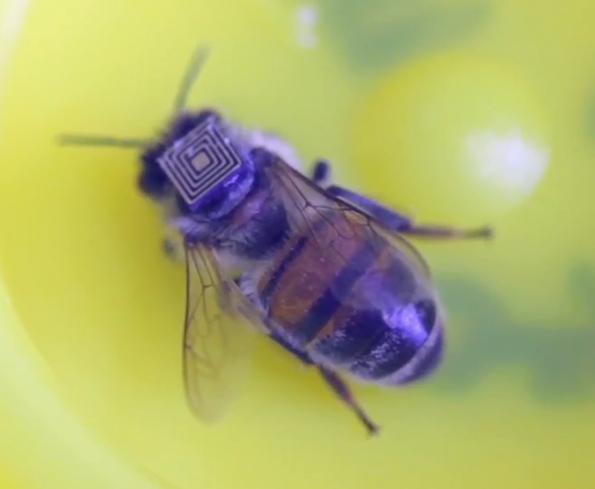

Imagine a world without bees: what would be different?

Introduction
Bees produce honey, but they are also necessary for pollinating many other plants, which in turn produce the foods we eat.

One day’s food
Think about a typical day and the food that you eat. List the different foods in a table. Include drinks as well.
Make sure that you record different foods separately (e.g. a ham and salad sandwich: bread, butter, ham, tomato, lettuce, cucumber, carrot).

This lists food crops that are pollinated by bees:
https://en.wikipedia.org/wiki/List_of_crop_plants_pollinated_by_bees
Identify which of the foods you have listed may have been ‘assisted’ by bees. Share your data with the rest of the class.
What percentage of the total amount of food was assisted by bees? What type of food was most affected?
Display your data appropriately.

