Investigating the maths inside:

Stargazing with the SKA
  - Activity 3B
  - Practical parabolas
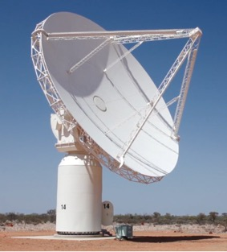
What are parabolas good for?

There are other uses for parabolic reflectors other than collecting radio waves from space

Do-it-yourself solar trough
Would you believe it is possible to boil water or cook sausages using a cardboard box and a thin sheet of cardboard? In this activity you will use the power of the sun and the reflective property of a parabolic surface to do just that.
Watch the video tutorial at https://youtu.be/TZGQ-Z_dPHk then try building one for yourself.
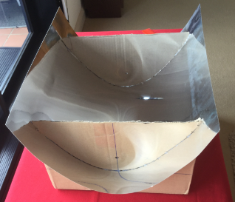 | 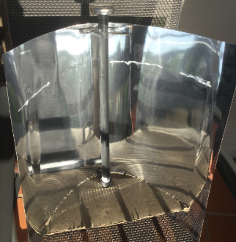
A home-made parabolic trough | A tube of water positioned along the focal axis

Improve the sound recording on your phone
This video shows you how to design a reflective parabolic paper dish to place near the microphone of your mobile phone so that it will pick up and record sound more efficiently.
www.youtube.com/watch?v=9QLwyrLsr0I

Acoustic mirrors (or parabolic microphones)
Research the use of acoustic mirrors. Between World Wars 1 and 2, prior to the invention of radar, acoustic mirrors were placed in various parts of England and Malta so that the locals could hear enemy planes approaching.
https://en.wikipedia.org/wiki/Acoustic_mirror
www.andrewgrantham.co.uk/soundmirrors/locations/denge
These are still used by bird-watchers to pick up the sound of birdcalls. During coverage of football games in the USA, portable parabolic microphones are used so that the commentators can hear what is being said on the field.
https://en.wikipedia.org/wiki/Parabolic_microphone
You could try building one: www.instructables.com/id/Dollar-Store-Parabolic-Mic

How to experience zero gravity
In this music video, the members of the band OK Go are inside a Russian plane that is used to train cosmonauts. The plane flies up and down along parabolic paths. When the plane is descending, the people inside experience zero gravity. The video was captured in one take, after many attempts.
This video explains how zero gravity flights work:
www.facebook.com/HiWeAreSweet/videos/543510315823210/
A little more information:
https://en.wikipedia.org/wiki/Upside_Down_%26_Inside_Out
www.youtube.com/watch?v=Q7lAIiAXpNI
www.stereogum.com/1858765/behind-the-scenes-of-ok-gos-zero-gravity-upside-down-inside-out-video

The Whispering Wall
In South Australia, the Barossa Reservoir has a dam wall with an amazing property: people 140 metres apart can hear each other clearly even when they are whispering. This video illustrates this phenomenon very clearly:
www.youtube.com/watch?v=JFydNDAmyFQ
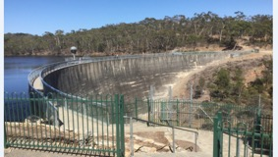

The building that melts cars
There is a building in London with a curved façade that unexpectedly was found to concentrate sunlight onto parked cars, causing serious damage to the cars.
https://en.wikipedia.org/wiki/20_Fenchurch_Street

